Job "TheVoice" of Project:

First Row:

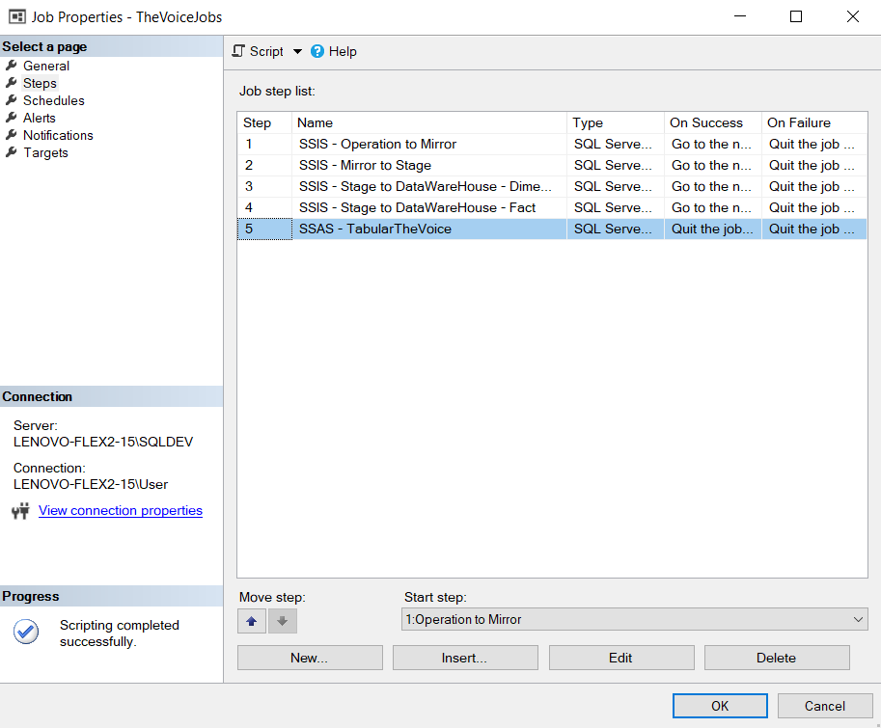

Script The Voice of Project:

USE [msdb]

GO

EXEC msdb.dbo.sp_update_jobstep @job_id=N'5f951154-990f-4f41-bc56-25671f4fcc23', @step_id=1, @step_name=N'SSIS - Operation to Mirror'

GO

USE [msdb]

GO

EXEC msdb.dbo.sp_update_jobstep @job_id=N'5f951154-990f-4f41-bc56-25671f4fcc23', @step_id=2, @step_name=N'SSIS - Mirror to Stage'

GO

USE [msdb]

GO

EXEC msdb.dbo.sp_update_jobstep @job_id=N'5f951154-990f-4f41-bc56-25671f4fcc23', @step_id=3, @step_name=N'SSIS - Stage to DataWareHouse - Dimension'

GO

USE [msdb]

GO

EXEC msdb.dbo.sp_update_jobstep @job_id=N'5f951154-990f-4f41-bc56-25671f4fcc23', @step_id=4, @step_name=N'SSIS - Stage to DataWareHouse - Fact'

GO

USE [msdb]

GO

EXEC msdb.dbo.sp_update_jobstep @job_id=N'5f951154-990f-4f41-bc56-25671f4fcc23', @step_id=5, @step_name=N'SSAS - TabularTheVoice'

GO

EXEC msdb.dbo.sp_attach_schedule @job_id=N'5f951154-990f-4f41-bc56-25671f4fcc23',@schedule_id=1009

GO

Time of job:

The job will run daily at a specific hour.

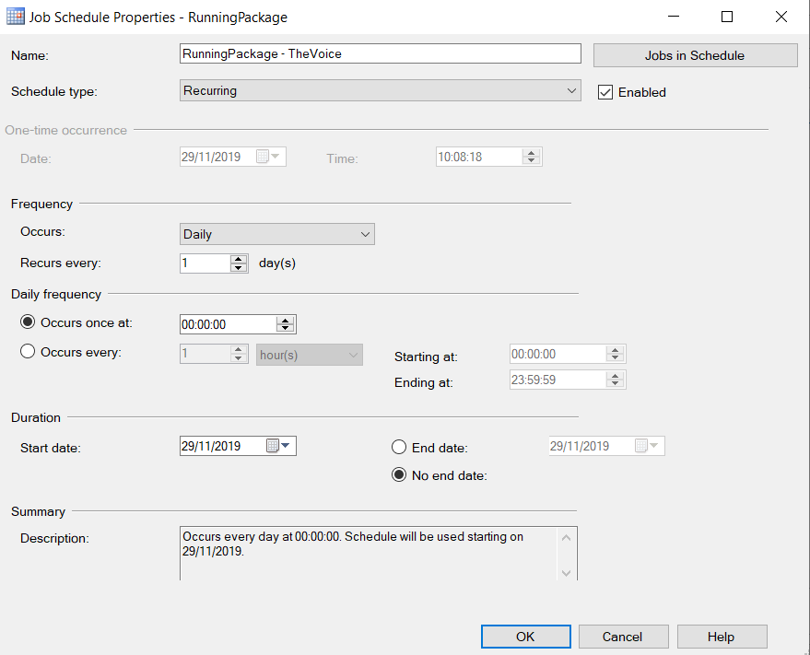

Second Row:

The second way is to create a new package in SSIS and take "Analysis Services Processing Tasks". And in it, under "Processing Settings", click "Add" and select the model we want to pass the Job Process.

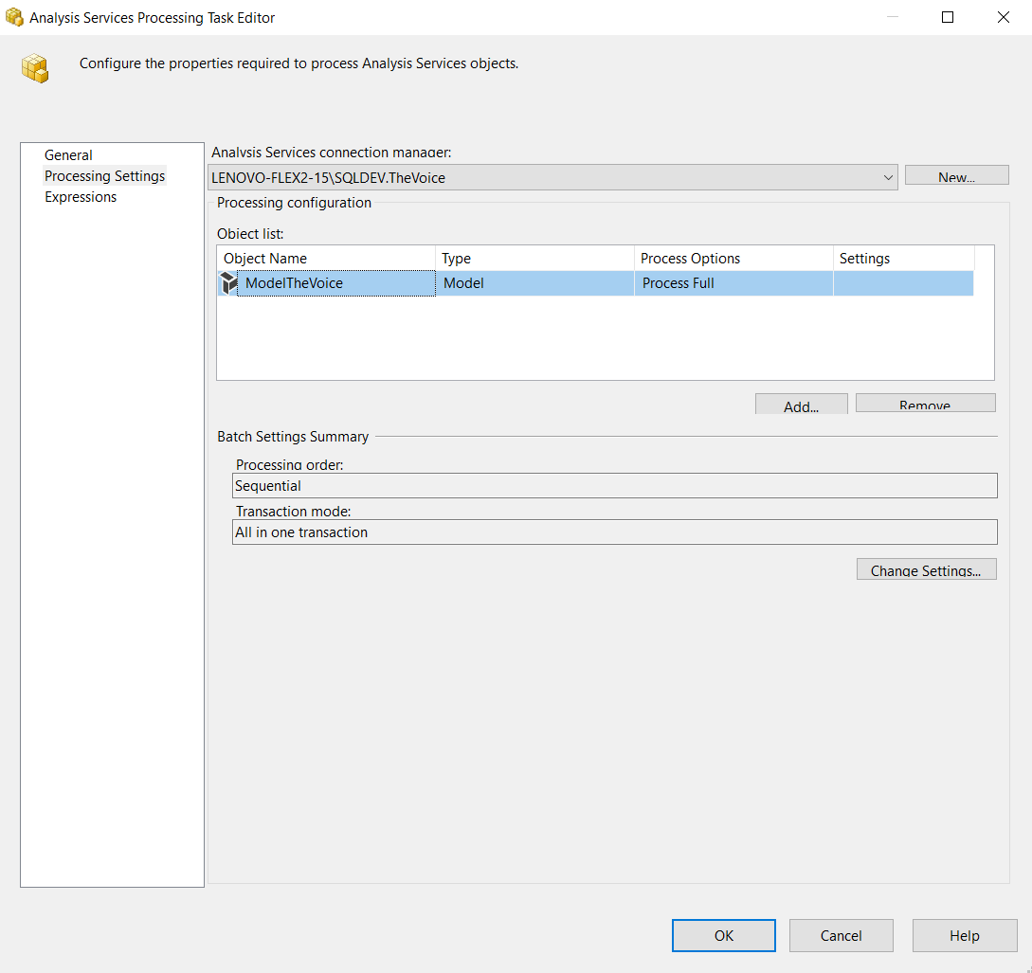

Script of Time when the job running:

USE [msdb]

GO

/****** Object: Step [Opperation to Mirror] Script Date: 29/11/2019 13:00:34 ******/

EXEC msdb.dbo.sp_delete_jobstep @job_id=N'3c6df45b-1dd6-4dd9-8e46-fa2da2ba9f59', @step_id=1

GO

USE [msdb]

GO

EXEC msdb.dbo.sp_add_jobstep @job_id=N'3c6df45b-1dd6-4dd9-8e46-fa2da2ba9f59', @step_name=N'Opperation to Mirror',

@step_id=1,

@cmdexec_success_code=0,

@on_success_action=1,

@on_fail_action=2,

@retry_attempts=0,

@retry_interval=0,

@os_run_priority=0, @subsystem=N'SSIS',

@command=N'/ISSERVER "\"\SSISDB\TheVoice\Integration Services Project1\Opp to Mrr.dtsx\"" /SERVER "\"LENOVO-FLEX2-15\SQLDEV\"" /Par "\"$ServerOption::LOGGING_LEVEL(Int16)\"";1 /Par "\"$ServerOption::SYNCHRONIZED(Boolean)\"";True /CALLERINFO SQLAGENT /REPORTING E',

@database_name=N'master',

@flags=0

GO

USE [msdb]

GO

EXEC msdb.dbo.sp_add_jobstep @job_id=N'3c6df45b-1dd6-4dd9-8e46-fa2da2ba9f59', @step_name=N'Mirror to Stage',

@step_id=2,

@cmdexec_success_code=0,

@on_success_action=3,

@on_fail_action=2,

@retry_attempts=0,

@retry_interval=0,

@os_run_priority=0, @subsystem=N'SSIS',

@command=N'/ISSERVER "\"\SSISDB\TheVoice\Integration Services Project1\Mrr to Stg.dtsx\"" /SERVER "\"LENOVO-FLEX2-15\SQLDEV\"" /Par "\"$ServerOption::LOGGING_LEVEL(Int16)\"";1 /Par "\"$ServerOption::SYNCHRONIZED(Boolean)\"";True /CALLERINFO SQLAGENT /REPORTING E',

@database_name=N'master',

@flags=0

GO

USE [msdb]

GO

EXEC msdb.dbo.sp_add_jobstep @job_id=N'3c6df45b-1dd6-4dd9-8e46-fa2da2ba9f59', @step_name=N'Stage to Data Warehouse - Dimation',

@step_id=3,

@cmdexec_success_code=0,

@on_success_action=3,

@on_fail_action=2,

@retry_attempts=0,

@retry_interval=0,

@os_run_priority=0, @subsystem=N'SSIS',

@command=N'/ISSERVER "\"\SSISDB\TheVoice\Integration Services Project1\Stg to DW - Dim.dtsx\"" /SERVER "\"LENOVO-FLEX2-15\SQLDEV\"" /Par "\"$ServerOption::LOGGING_LEVEL(Int16)\"";1 /Par "\"$ServerOption::SYNCHRONIZED(Boolean)\"";True /CALLERINFO SQLAGENT /REPORTING E',

@database_name=N'master',

@flags=0

GO

USE [msdb]

GO

EXEC msdb.dbo.sp_add_jobstep @job_id=N'3c6df45b-1dd6-4dd9-8e46-fa2da2ba9f59', @step_name=N'Stage to Data Warehouse - Fact',

@step_id=4,

@cmdexec_success_code=0,

@on_success_action=3,

@on_fail_action=2,

@retry_attempts=0,

@retry_interval=0,

@os_run_priority=0, @subsystem=N'SSIS',

@command=N'/ISSERVER "\"\SSISDB\TheVoice\Integration Services Project1\Stg to DW - Fact.dtsx\"" /SERVER "\"LENOVO-FLEX2-15\SQLDEV\"" /Par "\"$ServerOption::LOGGING_LEVEL(Int16)\"";1 /Par "\"$ServerOption::SYNCHRONIZED(Boolean)\"";True /CALLERINFO SQLAGENT /REPORTING E',

@database_name=N'master',

@flags=0

GO

USE [msdb]

GO

EXEC msdb.dbo.sp_add_jobstep @job_id=N'3c6df45b-1dd6-4dd9-8e46-fa2da2ba9f59', @step_name=N'Tabular Process',

@step_id=5,

@cmdexec_success_code=0,

@on_success_action=1,

@on_fail_action=2,

@retry_attempts=0,

@retry_interval=0,

@os_run_priority=0, @subsystem=N'SSIS',

@command=N'/ISSERVER "\"\SSISDB\TheVoice\Integration Services Project1\Package SSAS Tabular TheVoice.dtsx\"" /SERVER "\"LENOVO-FLEX2-15\SQLDEV\"" /Par "\"$ServerOption::LOGGING_LEVEL(Int16)\"";1 /Par "\"$ServerOption::SYNCHRONIZED(Boolean)\"";True /CALLERINFO SQLAGENT /REPORTING E',

@database_name=N'master',

@flags=0

GO

USE [msdb]

GO

DECLARE @schedule_id int

EXEC msdb.dbo.sp_add_jobschedule @job_id=N'3c6df45b-1dd6-4dd9-8e46-fa2da2ba9f59', @name=N'Job - TheVoice',

@enabled=1,

@freq_type=8,

@freq_interval=1,

@freq_subday_type=1,

@freq_subday_interval=0,

@freq_relative_interval=0,

@freq_recurrence_factor=1,

@active_start_date=20191129,

@active_end_date=99991231,

@active_start_time=0,

@active_end_time=235959, @schedule_id = @schedule_id OUTPUT

select @schedule_id

GO.